## Figures

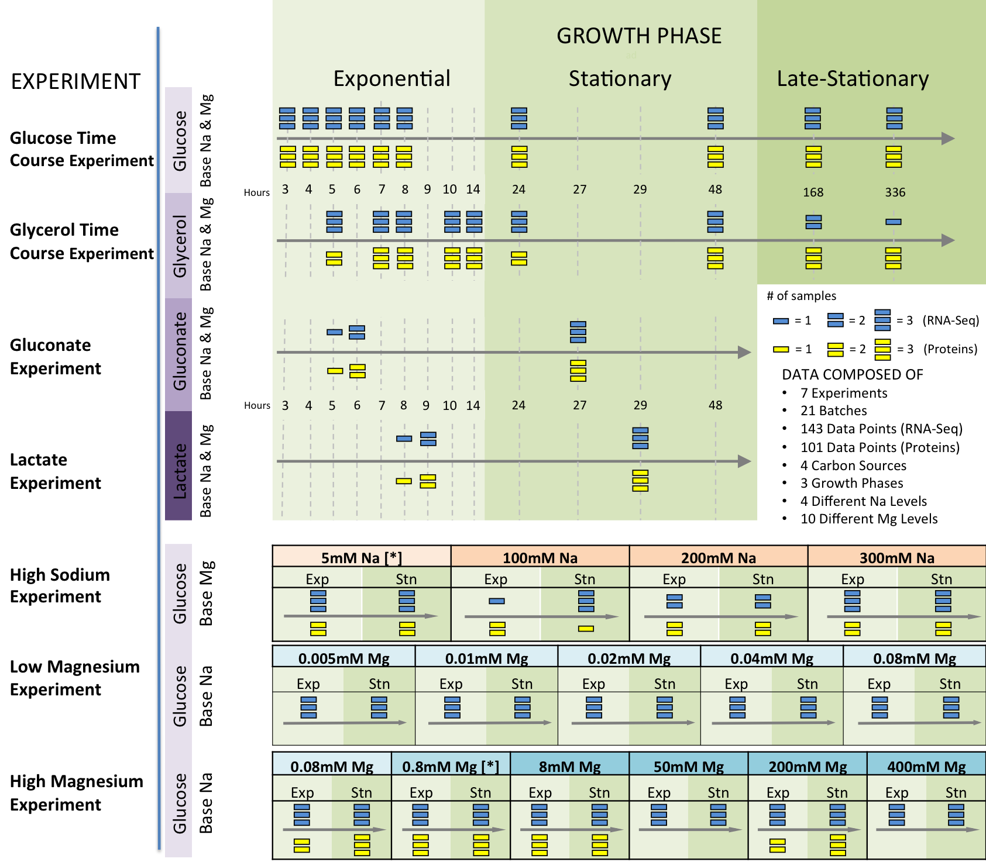

Figure 1: Experimental setup. We performed seven different experiments, in which we varied the duration of growth and the temporal density of sampling, the carbon source, and ion concentrations. For each experimental condition, bacteria were grown in three biological replicates. We subsequently performed whole-transcriptome RNA-Seq for all samples mass-spec proteomics for the majority of them. After quality control, we retained between one and three RNA-Seq and/or proteomics samples for each condition (indicated by the number of horizontal bars in the figure). We considered four different carbon sources: glucose, glycerol, gluconate, and lactate; we also considered high sodium and both low and high magnesium levels. For the time-course and carbon-source experiments, we used base-level Na (5mM) and Mg (0.8mM) throughout (indicated by [*] in the sodium and magnesium experiments).

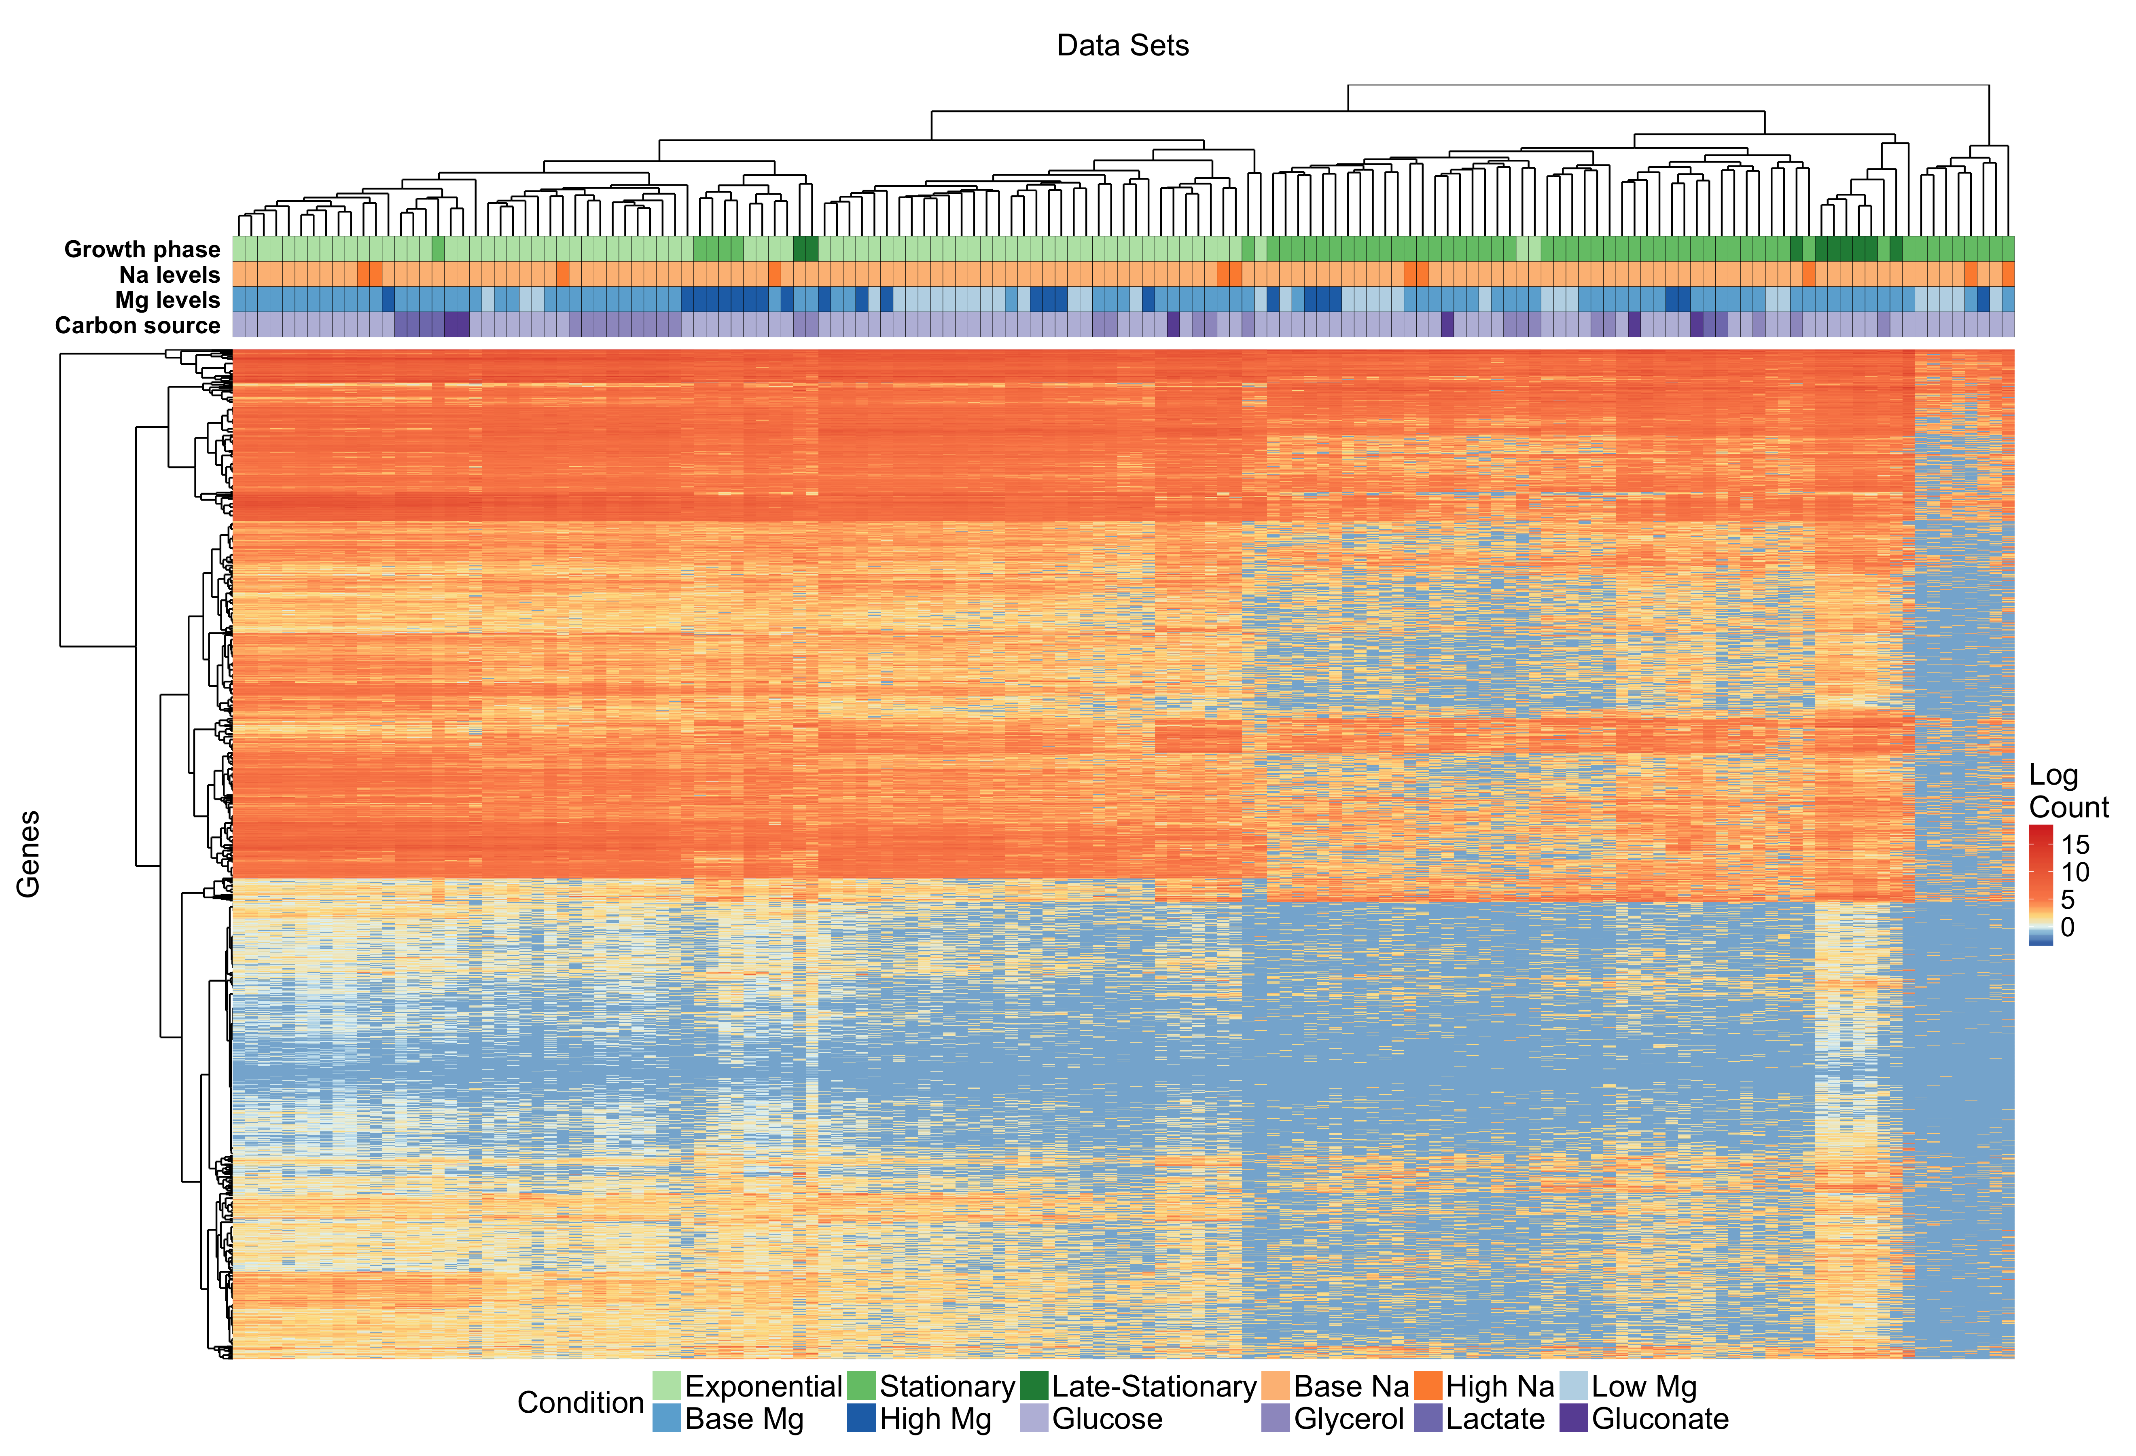

Figure 2: Clustering of mRNA abundances. The heatmap shows 4279 mRNA abundances for each of 143 samples, clustered both by similarity across genes and by similarity across samples. The growth conditions for each sample are indicated by the color coding along the top of the heatmap; the color coding is defined in the legend at the bottom.

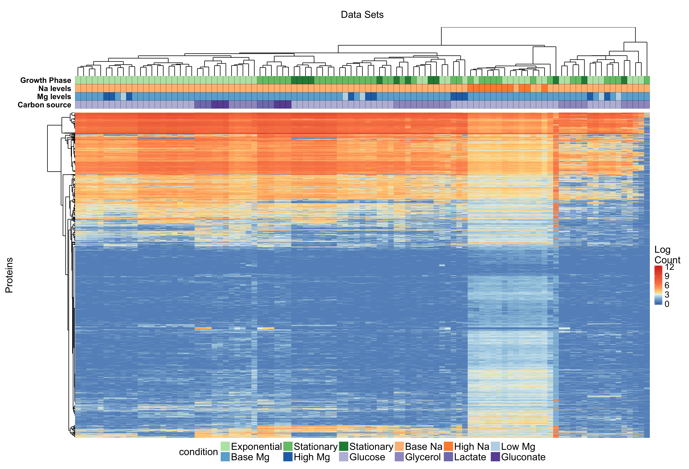

**Figure 3: Clustering of protein abundances.** The heatmap shows 4279 protein abundances for each of 101 samples, clustered both by similarity across genes and by similarity across samples. The growth conditions for each sample are indicated by the color coding along the top of the heatmap; the color coding is defined in the legend at the bottom.



Figure 4. Number of differentially expressed genes under different conditions. We separately analyzed mRNA and protein abundances, each for both exponential and stationary growth phase. In all for cases, gene expression levels were compared to the corresponding condition with glucose as carbon source and baseline sodium and magnesium levels. Differentially expressed genes were defined has having at least a two-fold change relative to baseline and a false-discovery rate <0.05.

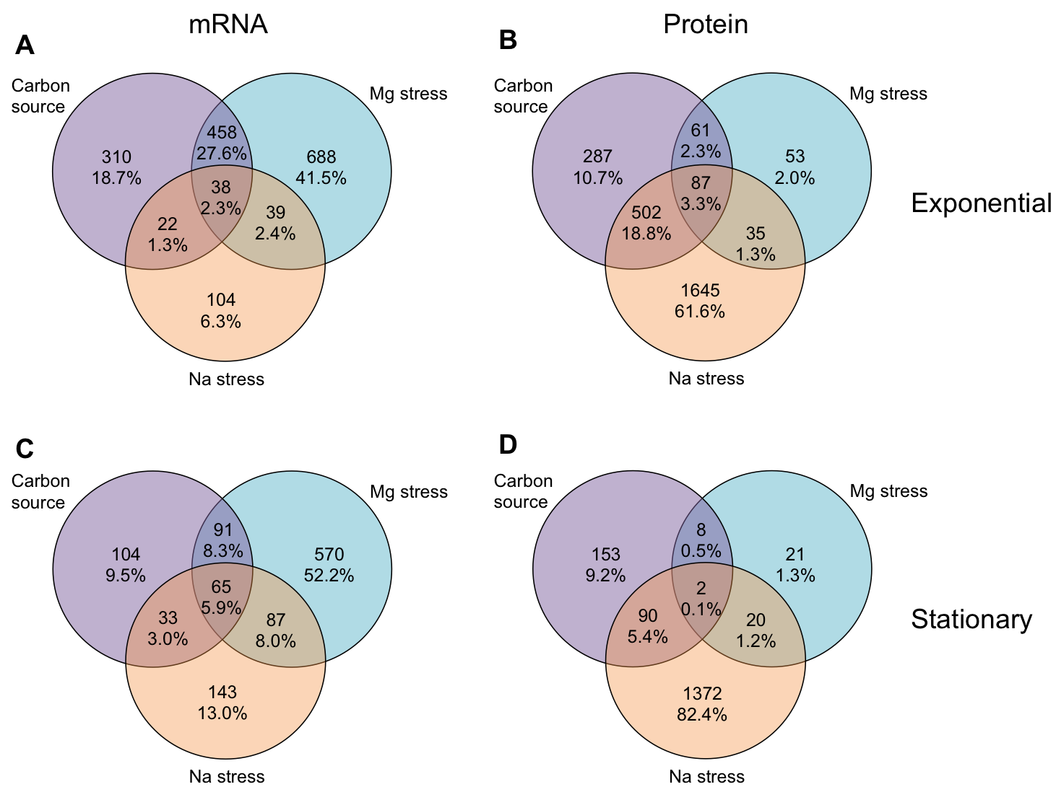

Figure 5: Overlap of differentially expressed genes among conditions. For all differentially expressed genes (identified as in Figure 4), we determined to what extent they were unique to specific conditions or appeared in multiple conditions. For simplicity, we here lumped all carbon-source experiments, all sodium experiments, and all magnesium experiments into one group each. Overall, we found relatively little overlap in the differentially expressed genes among these conditions. (A) mRNA, exponential phase. (B) protein, exponential phase. (C) mRNA, stationary phase. (D) protein, stationary phase.

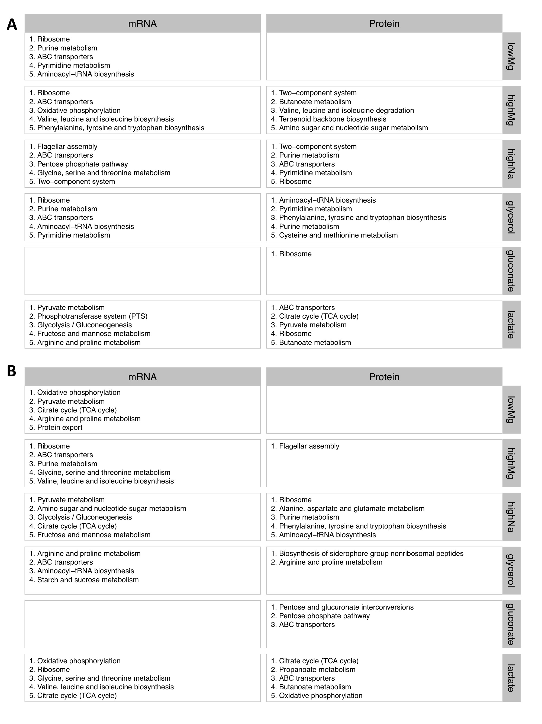

**Figure 6:** **Significantly differentially expressed KEGG pathways.** For each condition, we show the top-5 differentially expressed KEGG pathways as determined by either mRNA or protein abundances. (A) exponential phase. (B) stationary phase. *Need to verify this.*



**Figure 7:** **Significantly differentially expressed KEGG pathways and associated genes at high Mg levels in exponential phase, as determined by mRNA abundances.** The top differentially expressed KEGG pathways are shown along the y axis, and the relative fold change of the corresponding genes is shown along the x axis. For each KEGG pathway, we show up to 10 of the most significantly changing genes.



**Figure 8:** **Significantly differentially expressed KEGG pathways and associated genes at high Mg levels in stationary phase, as determined by mRNA abundances.** The top differentially expressed KEGG pathways are shown along the y axis, and the relative fold change of the corresponding genes is shown along the x axis. For each KEGG pathway, we show up to 10 of the most significantly changing genes. Notably, most genes are up-regulated under this condition, unlike any of the other Mg stress conditions (Figure 4).



Figure 9. Number of differentially expressed, metabolism-related genes under ionic stress conditions. Metabolism-related mRNAs and proteins are generally down-regulated under ionic stress conditions, with one exception of stationary phase high Mg mRNA reads.

## Tables

Table 1: Clustering of mRNA and protein abundances by different growth conditions. The *z* scores represent mean cophenetic distances between all pairs of conditions with the same label, normalized by the distribution of mean distances obtained after randomly reshuffling condition labels. The overall *z* score tests for significant clustering within a given variable, and the individual *z* score tests for significant clustering within a given condition. Significant clustering (defined as |*z*|>2) is indicated with a *.

|  |  |  |  |  |  |  |  |
| --- | --- | --- | --- | --- | --- | --- | --- |
| **mRNA** | | | | | | | |
| **Variable** | **Overall *z* score** |  | **Condition** | | ***z* score** |  | **# samples** |
| Growth phase | −23.99 | * | Exponential | | −12.27 | * | 77 |
| Stationary | | 1.08 |  | 57 |
| Late stationary | | −3.04 | * | 9 |
| Carbon source | 1.16 |  | Glucose | | 1.23 |  | 107 |
| Glycerol | | −1.08 |  | 24 |
| Lactate | | −1.42 |  | 6 |
| Gluconate | | −0.42 |  | 6 |
| Mg Level | −1.46 |  | Low Mg | | 1.01 |  | 35 |
| Base Mg | | −0.90 |  | 85 |
| High Mg | | −2.17 | * | 23 |
| Na Level | −1.54 |  | Base Na | | −1.53 |  | 132 |
| High Na | | 1.36 |  | 11 |
| Batch number | −2.82 | * |  | |  |  |  |
|  |  |  |  | |  |  |  |
|  |  |  |  | |  |  |  |
| **Protein** | | | | | | | |
| **Variable** | **Overall *z* score** |  | **Condition** | ***z* score** | |  | **# samples** |
| Growth phase | −4.21 | * | Exponential | −2.19 | | * | 53 |
| Stationary | −0.14 | |  | 36 |
| Late stationary | −0.37 | |  | 12 |
| Carbon source | −3.15 | * | Glucose | −1.80 | |  | 64 |
| Glycerol | −0.75 | |  | 25 |
| Lactate | −3.26 | | * | 6 |
| Gluconate | −3.22 | | * | 6 |
| Mg Level | 0.82 |  | Low Mg | −1.11 | |  | 5 |
| Base Mg | 1.08 | |  | 85 |
| High Mg | −2.86 | | * | 11 |
| Na Level | −4.78 | * | Base Na | −3.31 | | * | 90 |
| High Na | −8.01 | | * | 11 |
| Batch number | −23.39 | * |  |  | |  |  |